# RAW_16 Documentaion

DSBfm Mug1.jpg and DSBfm Mug2.jpg are the B Mode images for which raw data is given in the binary file “raw Data.bin”. The only difference is data is captured after 103uS after transmit and for approximately 100uS only.

### File Format:

Please read into this C Array:

Int16 RawData[8][16][1024*8]

#### [8] = Frame

|  |  |
| --- | --- |
| Frame | Transmit Beam Angle (Degrees) |
| 0 | 26.25 |
| 1 | 18.75 |
| 2 | 11.25 |
| 3 | 3.75 |
| 4 | -3.75 |
| 5 | -11.25 |
| 6 | -18.75 |
| 7 | -26.25 |

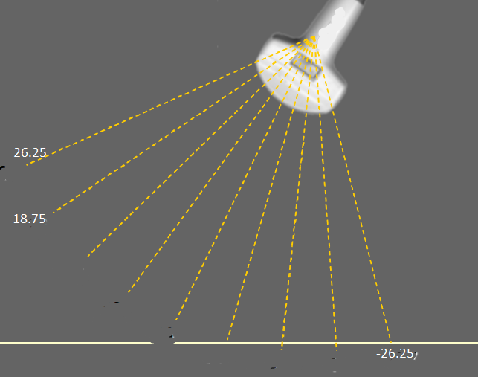

#### [16]=Channels

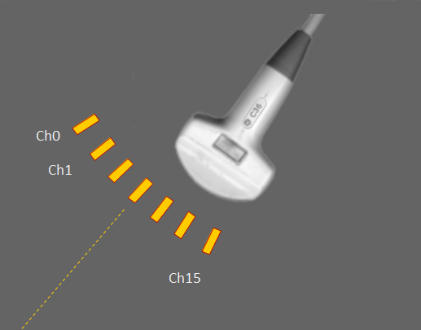

See diagram for Channel number orientation

#### [1024*8] = ADC data :

* Starting from Near to Far
* ADC sampling rate is 80MHz
* Depth Start is 103uS

#### Probe Geometry

* Phased Array Probe
* Pitch 1.2mm
* No. of elements : 16
* Transmit Frequency: 3.5MHz